**How to Compile and Run a C Program on Ubuntu Linux**

Bheemappa H

MSRIT, Jan-2020

This document shows how to compile and run a C program on Ubuntu Linux using the gcc compiler.

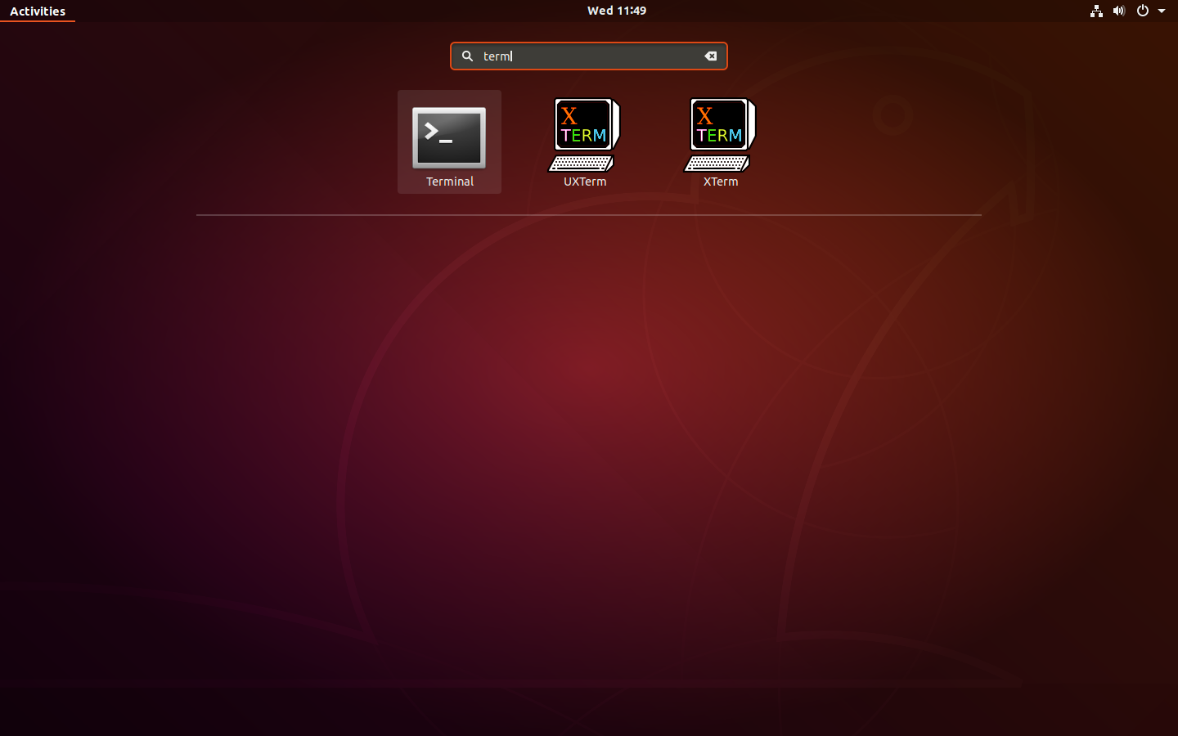**Step 1. Open up a terminal**

**-** Go to “Dash tool “ ( located as the left topmost item )

**- Search for the terminal application**

**- Open up a terminal by clicking on the icon.**

**Or**

**shortcut key to open terminal**

press **CTRL+ALT+t** to open terminal

**Step 2. Use a VI editor to create the C source code.**

**Commands** **SCREEN**

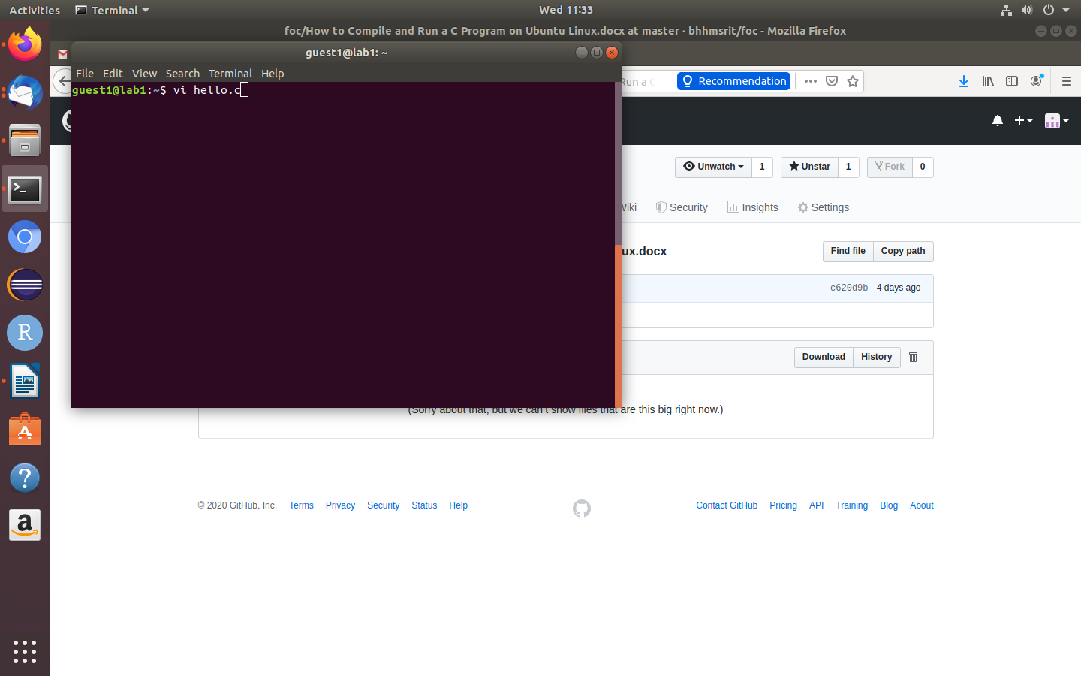1. Type the command

***vi hello.c***

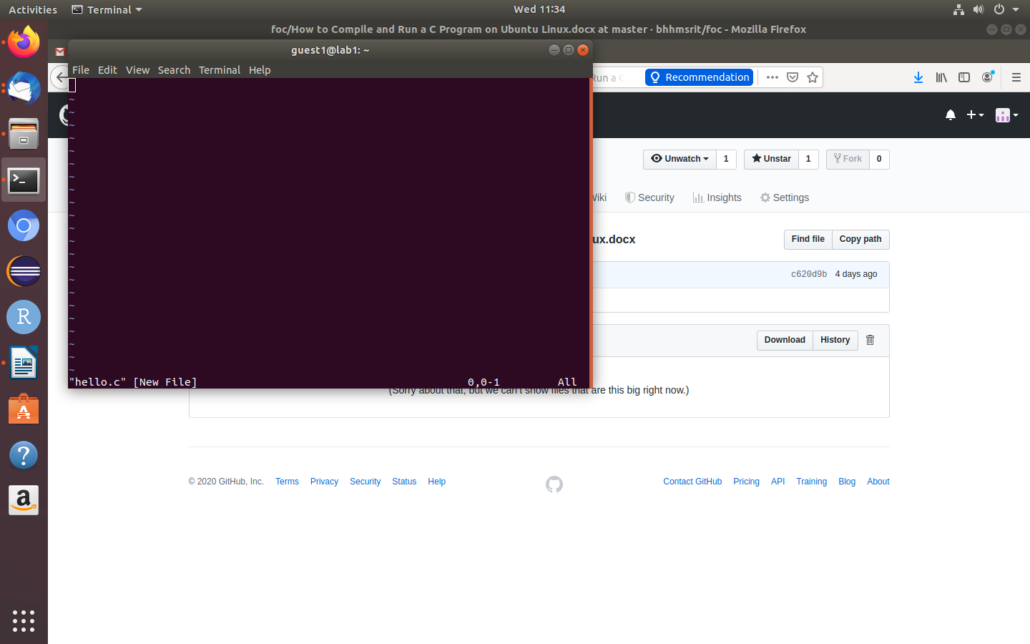2. hit enter

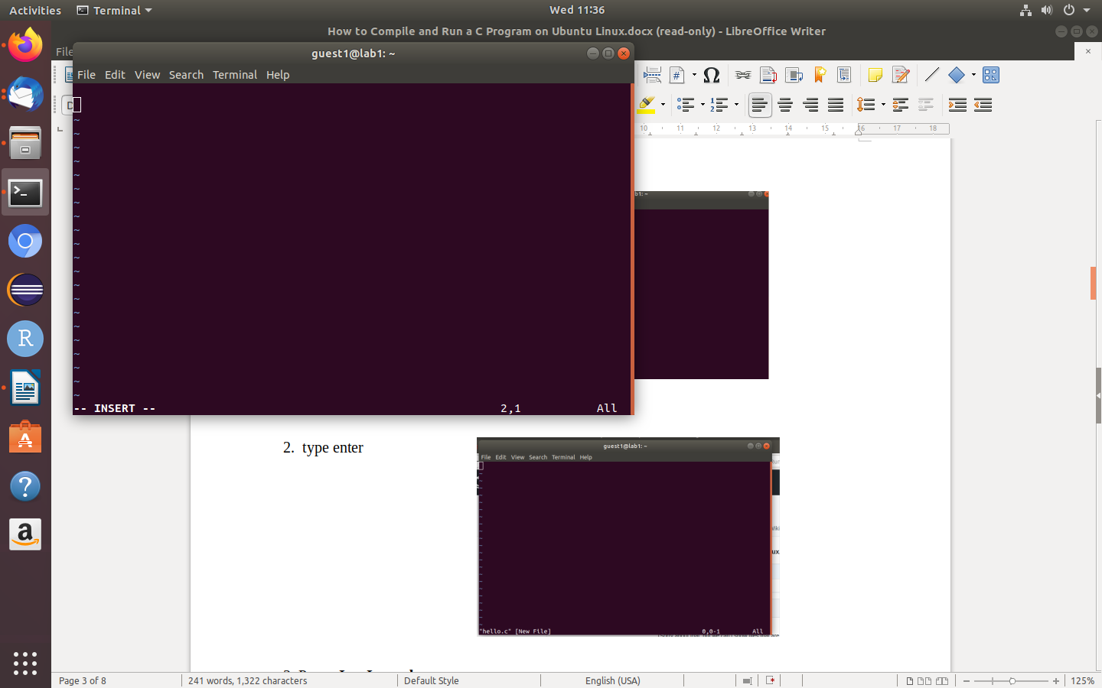

3. Press **I or Insert button to enter text**

in helo.c program (Insert mode)

**after press( I or Insert button)**

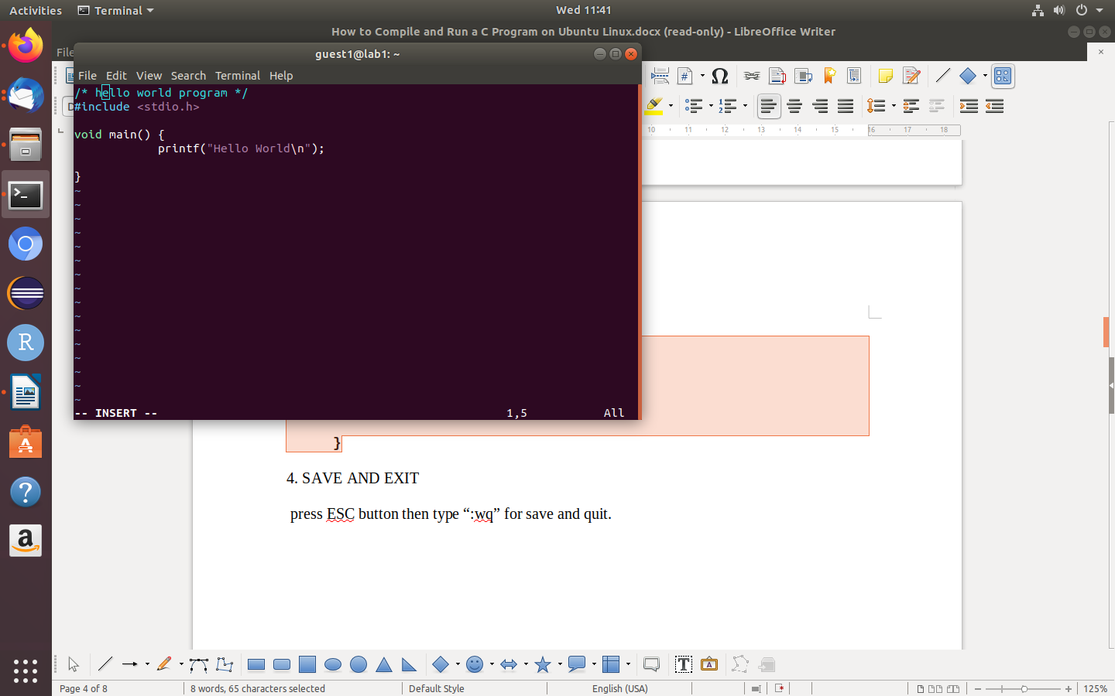3. then enter the C source code below:

**#include <stdio.h>**

**void main() {**

**printf("Hello World\n");**

**}**

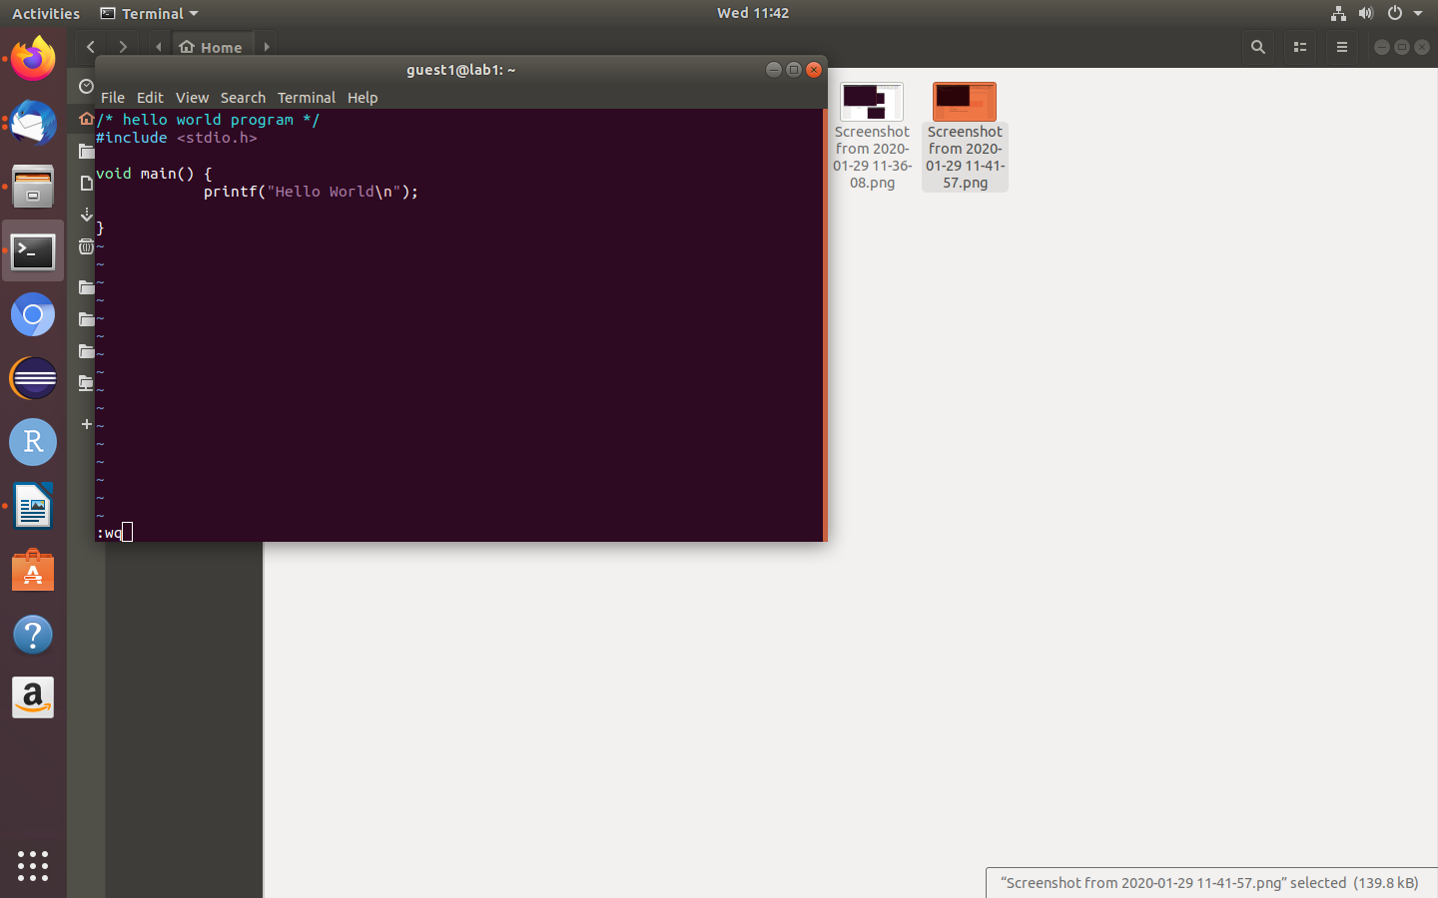4. SAVE AND EXIT ( save program and quit)

press ESC button then type

*“:wq”*

hit enter

**Step 3. Compiling C program**

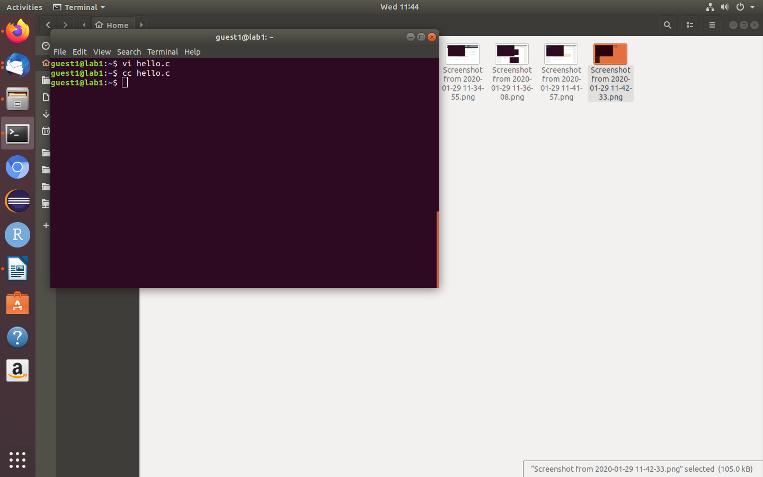

type

***cc hello.c***

(after **cc hello.c** , if the prompt appears it means program compiled successfully.)

( compiler will compile the file **hello.c** and creates to an executable called **a.out.)**

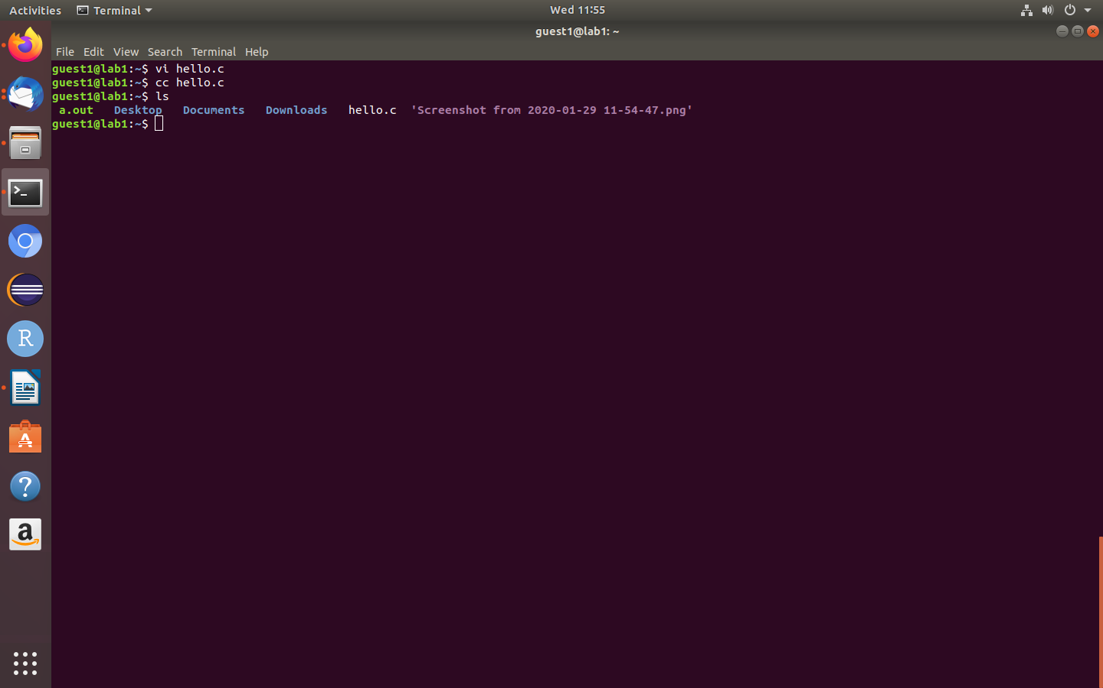

**Step 4. Execution of hello.c C program**

**1. type *ls***

**(to check the compiled file(*a.out*) created not )**

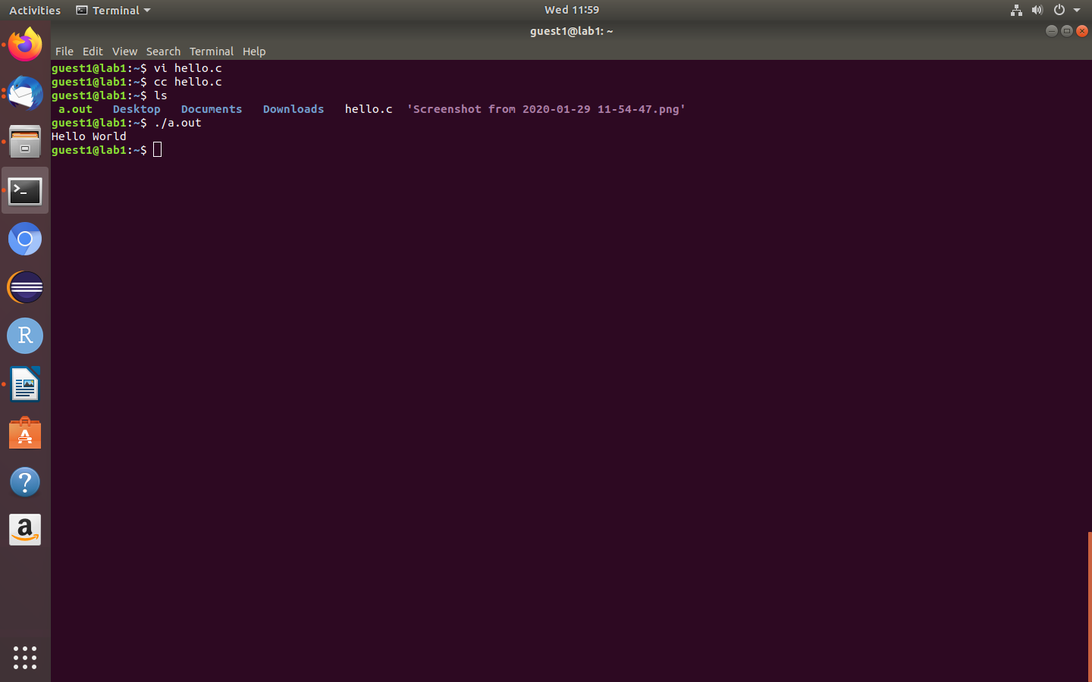

**2. Execute the program**

**type :**

***./a.out***

**(hit enter to see the output)3[1]**

1. <https://bhhmsrit.github.io/foc/> bhh